Steganography Tool

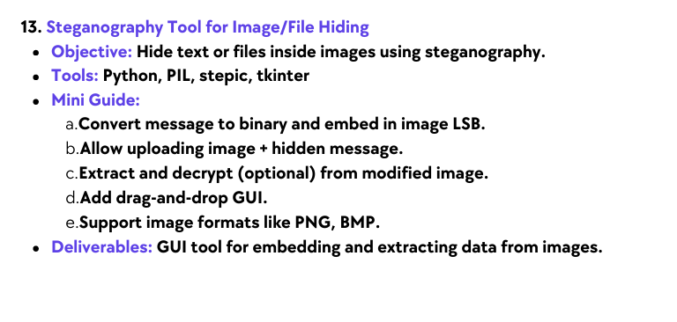

Elevate Labs Internship Report
Name: Soham Dutta Email: sohamdutta.haldia@gmail.com

Contents
Sl. | Name | Pg. No.
1 | Project Overview | 2
2 | GUI by tkinter | 2
3 | Encoding | 2
4 | Decode | 3
5 | Conclusion | 3

1. Project Overview
Title: Steganography Tool for Text Hiding

Purpose

Basic concept of image based steganography- hiding secret messages within digital images using the Least Significant Bit (LSB) technique. This project helps in understanding how information can be concealed and later retrieved without visibly altering the cover image, providing insights into data security and privacy techniques.

Key Features
- Hides secret text messages inside PNG images
- Uses Least Significant Bit (LSB) method for secure and invisible embedding
- Provides simple encoding and decoding scripts for easy use.

2. GUI by tkinter
This Screenshot shows the tkinter GUI which has attributes like image selecting, message input and have buttons and type field for the requirements.
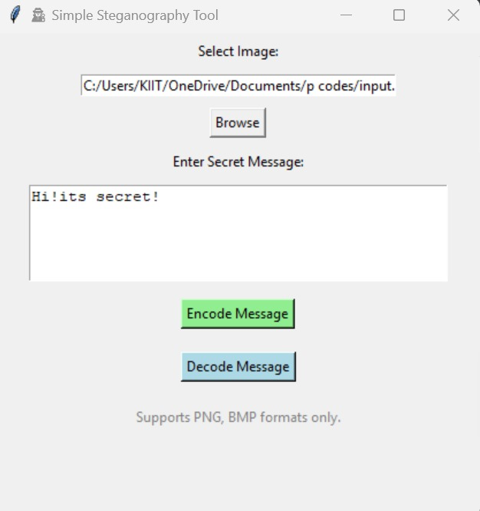

3. Encoding
Hides the message inside the image using the LSB method, and saves the resulting stego image.
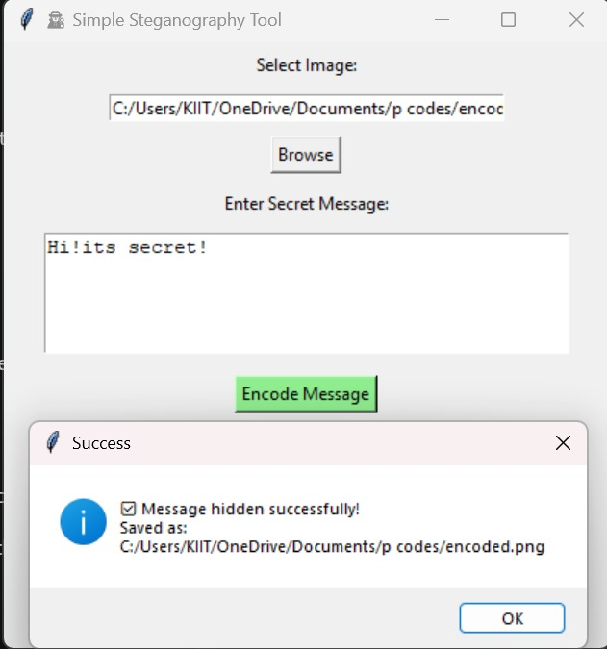

4. Decode
Here, the encoded image is taken and decode/shows the hidden message.
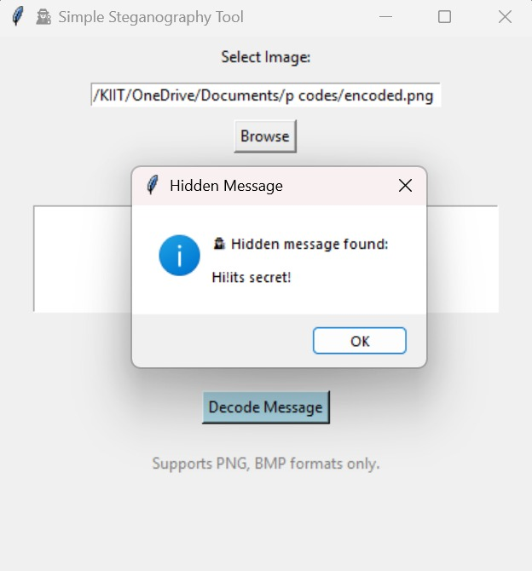

5. Conclusion
The project successfully demonstrates the principles of image based steganography using Python. Secret messages were effectively hidden in PNG images without altering their visible appearance, and the messages were accurately retrieved using the decoder script. It highlights the potential of steganography in protecting sensitive information and lays a foundation for more advanced projects in digital security and privacy.

